# Tutorial of mesh simulation plugin

## Step 0 Install the plugin

1. Open Rhino6, grasshopper. And the “Components Folder” by following the picture below.

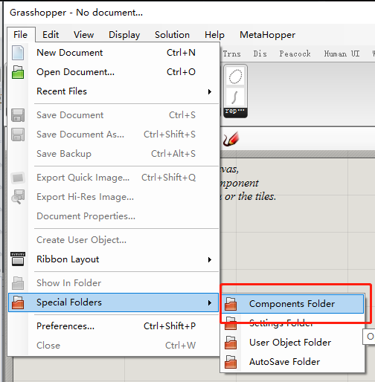

1. Copy the “MeshSimulation.gha” file to the “Components Folder”.

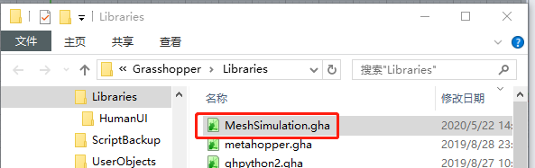

1. Close the folder, grasshopper and Rhino 6, **restart** Rhino6 and grasshopper.
2. Open the “experiment.gh” file. If everything works well, the Rhino and grasshopper interface will show like the picture below.

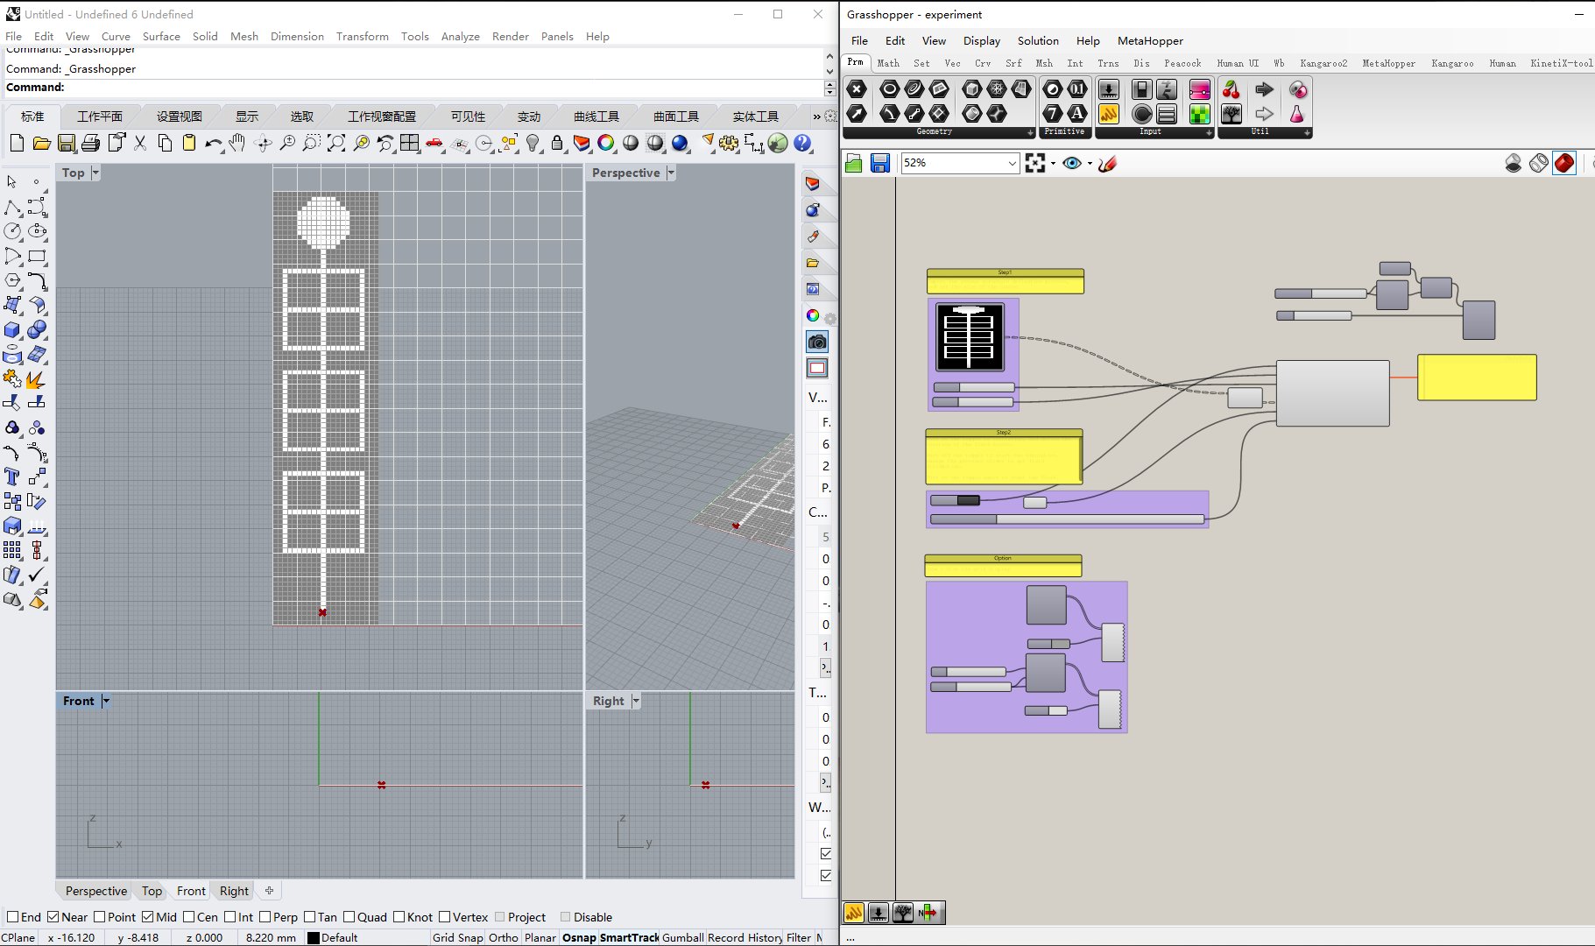

## Step 1 Prepare the venous structure

1. **Prepare a venous structure definition picture.**

The picture below is how I draw it in photoshop.   
Tips:   
- Save the picture in PNG or BMP.  
- The size of the picture is better no larger then 100×100, larger picture may get stuck a little when doing the simulation.

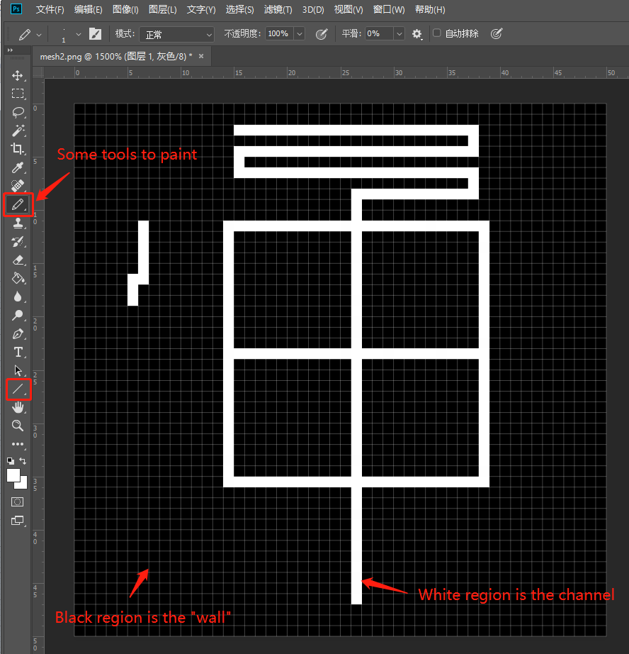

1. **Import the venous structure definition picture.**

Follow the 5 sub-steps below.

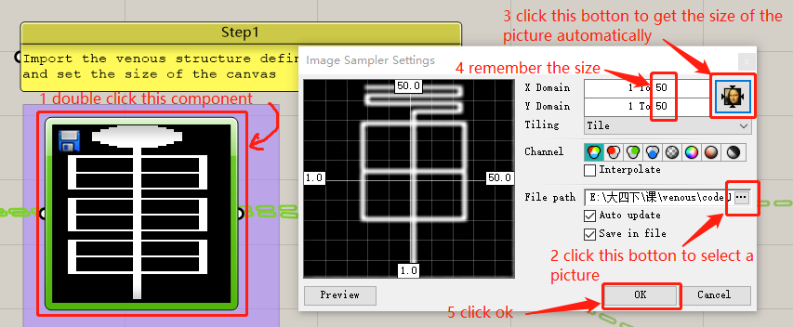

1. **Set the size of the canvas.**

Set the “Extent X” & “Extent Y” according to the size of the picture we get. (X = width, Y = height)

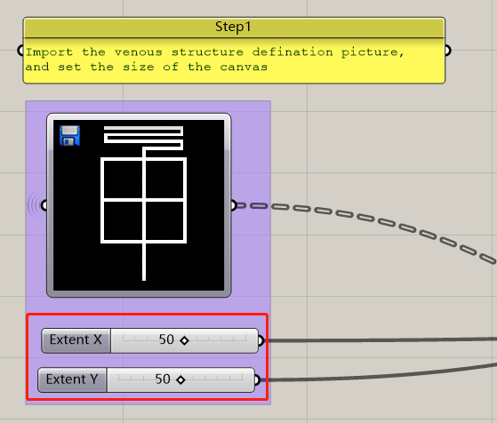

## Step 2 Simulation

1. **Define the location of the fluid source and initialize.**

Follow the 2 sub-steps below.

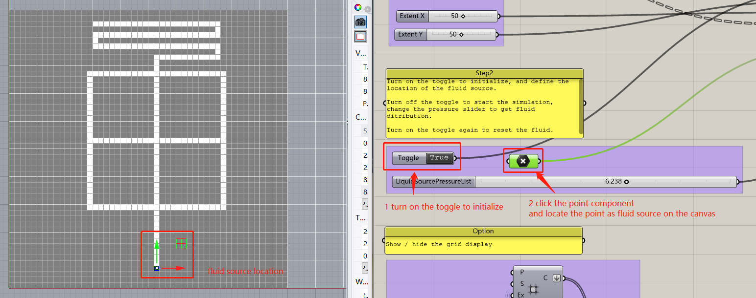

1. **Start the simulation.**

Turn off the toggle to start the simulation, then change the pressure.

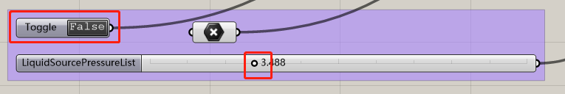

1. **Reset the fluid.**

Turn on the toggle again and the fluid will be reset.

## Optional Step

Show/hide the grid display by flowing the 2 sub-steps below.

